Problem Statement: You work for XYZ Corporation. The company has decided to move its infrastructure to AWS to leverage the storage services offered by AWS. While migrating, you are asked to perform the following tasks:

1. Ensure that any amount of data can be stored on the cloud and can be retrieved at anytime from anywhere on the web
   1. Create a S3 Bucket and set it to access publicly to access anywhere from the web.

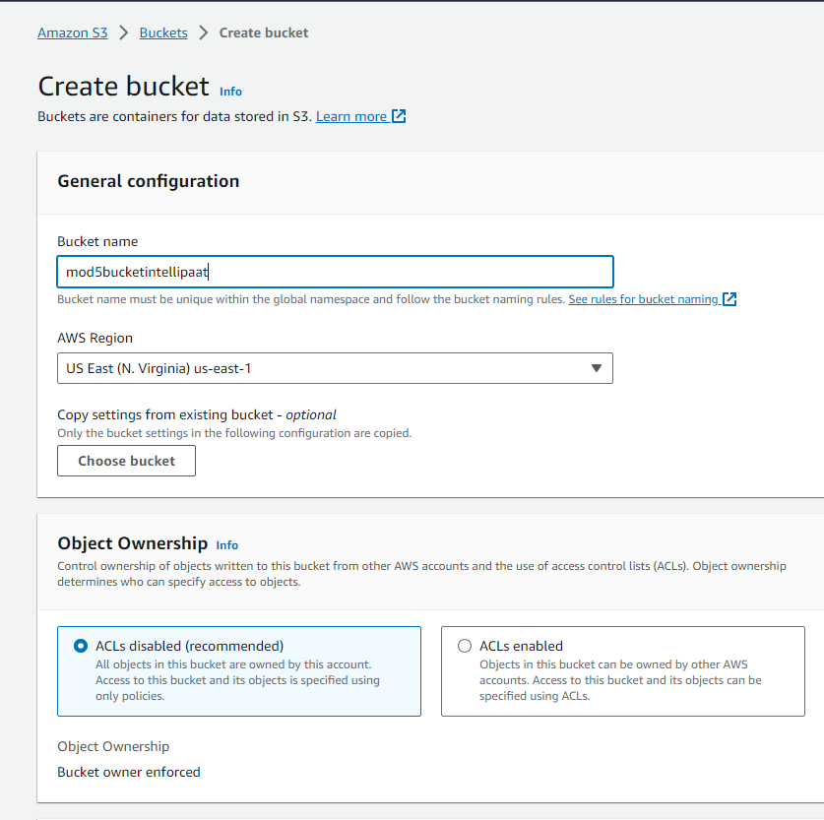

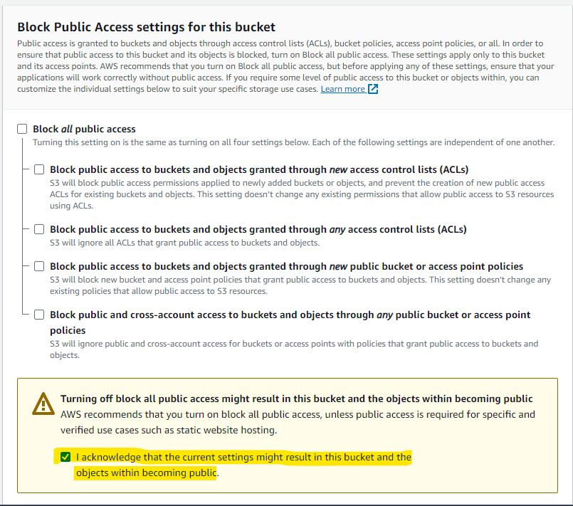

* 1. Enable Bucket Versioning for Point 3 (Retrieve the old version of a file if the content of the current version of the file is compromised accidentally)

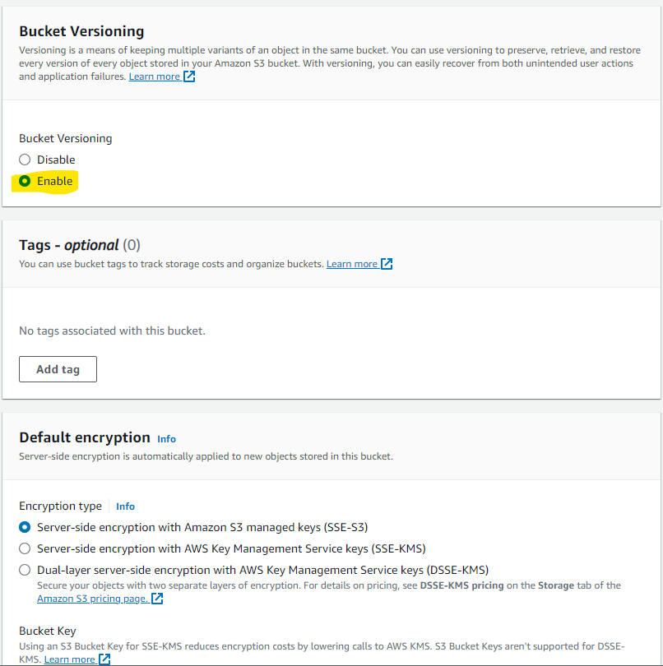

1. Manage the lifecycle of the data that is being stored on the cloud so that it gets deleted automatically after 75 days
   1. Create a Lifecyle Rule to Expire Objects after 75 Days

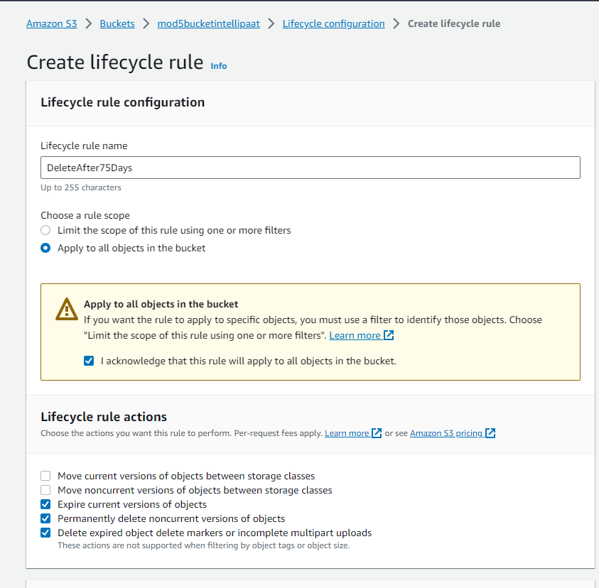

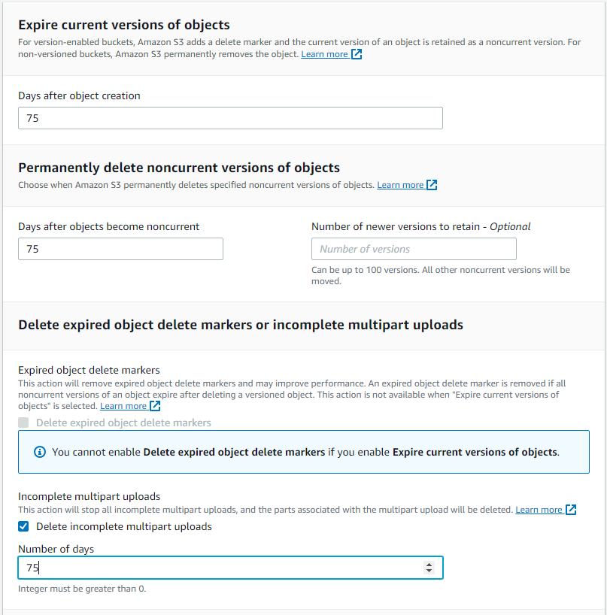

1. Retrieve the old version of a file if the content of the current version of the file is compromised accidentally.
   1. Deleted Old Object, as observed it’s still present in Bucket (Versioning)

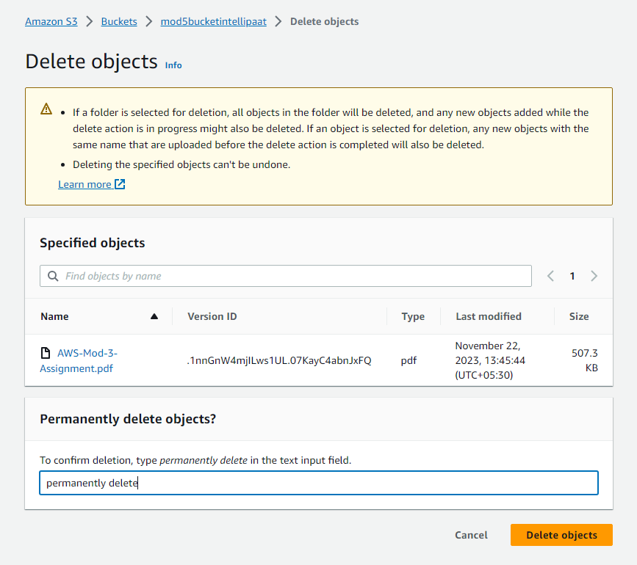

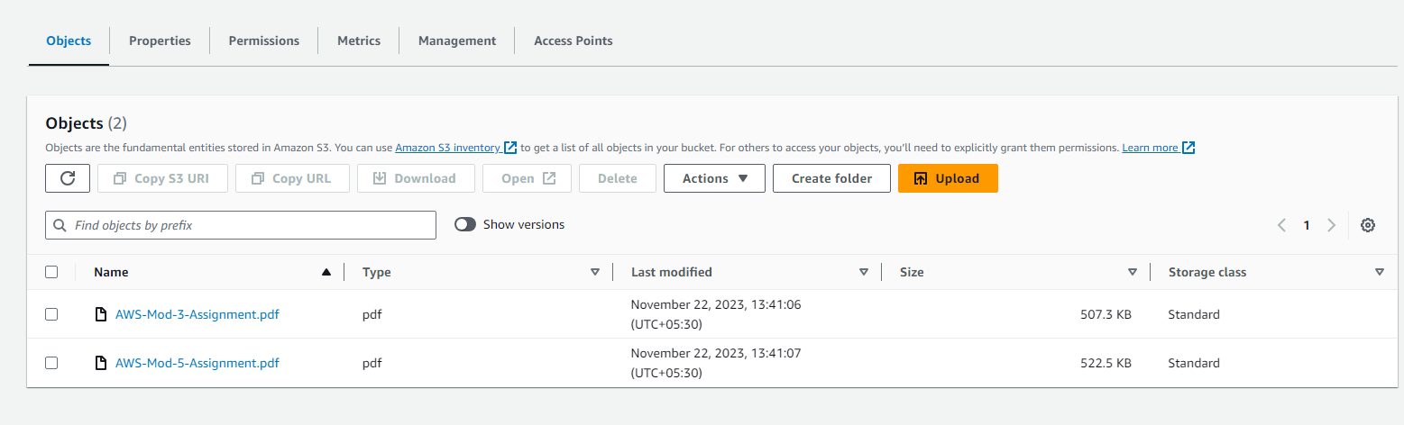

4. Host your static website on the AWS cloud using the domain name created in the Module 3 Route 53 assignment (freenom is not working temporarily, unable to get a domain hence skipping this)

5. Display an error page if the proper domain name is not used while attempting to access the company’s website (freenom is not working temporarily, unable to get a domain hence skipping this)

6. Create an S3 access point for the created bucket, and upload a file to the bucket from the CLI

a. Create Access Point

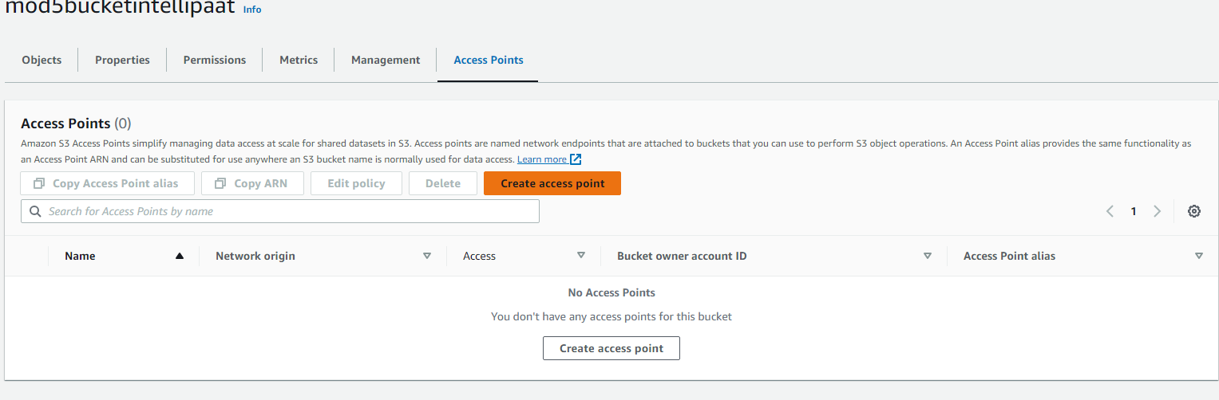

* 1. Upload a file via CLI.

